**WEB DEVELOPMENT PROJECT**

DESCRIPTION OF PROJECT:

Create a simple quiz game. Store questions and answers in an array or database, present questions to the user, and provide feedback on their answers using HTML, CSS and using JAVASCRIPT.

1.

**HTML FILE**

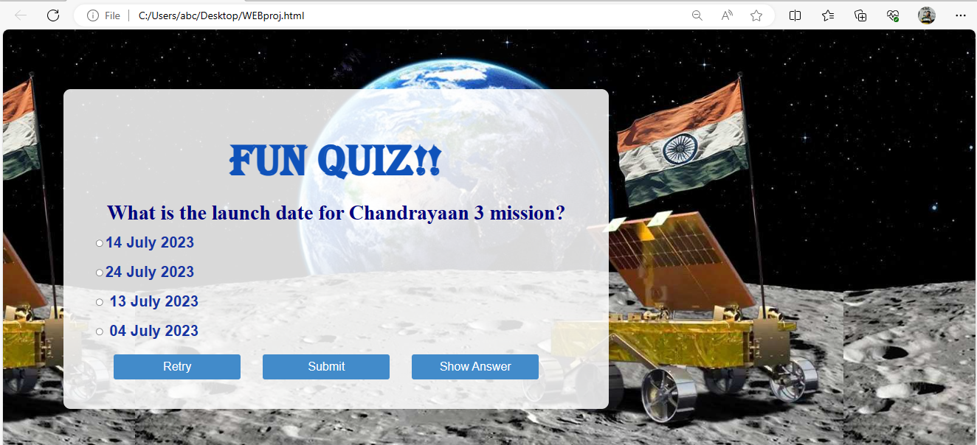

CODE

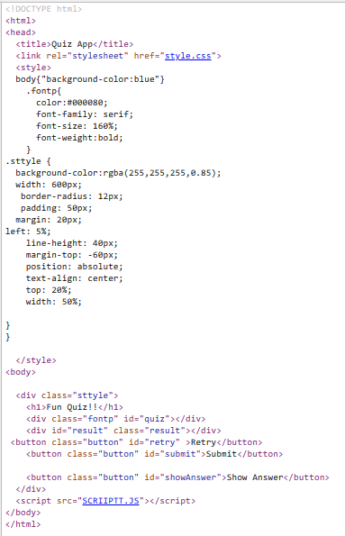

**2.**

**CASCADING STYLE SHEET CODE**

body {

font-family: sans-serif;

background: #b9b3a9;

display: flex;

flex-direction:column;

justify-content: center;

background-image: url("moon.jpg" );width:1000px;

height: 500px;

background-position: center;

}

.containergs {

width: 450px;

padding: 20px;

margin-top: 80px;

background-color: #fff;

box-shadow: 0 2px 4px rgba(0, 0, 0, 0.1);

border-radius: 20px;

}

h1 {

text-align: center;

text-transform:uppercase;

color:#0F52BA;

font-family:algerian;

font-size:74px;

}

.question {

font-weight: bold;

margin-bottom: 10px;

font-family:serif;

font-size:135%;

}

.options {

margin-bottom: 20px;

color:#1434A4;

font-family:sans-serif;

text-align:left;

}

.option {

display: block;

margin-bottom: 10px;

}

.button {

display: inline-block;

padding: 10px 20px;

background-color: #428bca;

color: #fff;

border: none;

cursor: pointer;

font-size: 20px;

border-radius: 4px;

transition: background-color 0.3s;

margin-right: 33px;

width:215px;

}

.button:hover {

background-color: #3071a9;

}

.result {

text-align: center;

margin-top: 20px;

font-weight: bold;

}

.hide{

display: none;

}

**3.**

**JAVASCRIPT CODE**

const quizData = [

{

question: 'What is the launch date for Chandrayaan 3 mission?',

options: ['24 July 2023','14 July 2023',' 13 July 2023',' 04 July 2023'],

answer: '14 July 2023',

},

{

question: 'The Chandrayaan 3 mission rover is known as?',

options: ['Vikram',' Bheem',' Pragyaan',' Dhruv'],

answer: 'Pragyaan',

},

{

question: 'The mission life of the Lander and rover equal to?',

options: ['14 Earth Days','24 Earth Days','16 Earth Days','12 Earth Days'],

answer: '14 Earth Days',

},

{

question: 'Which launcher is used for Chandrayaan 3?',

options: ['GSLV','LVSM','GSLV-Mk3','PSLV'],

answer: 'GSLV-Mk3',

},

{

question: 'The mission objectives of Chandrayaan 3?',

options: [

'To demonstrate Rover roving on the moon',

'To demonstrate a Safe and Soft Landing on Lunar Surface',

'To conduct in-situ scientific experiments',

'All of the above'],

answer: 'All of the above',

},

{

question: 'How much did the Chandrayaan 3 mission cost?',

options: ['1200 Crores','960 Crores','600 Crores','540 Crores'],

answer: '600 Crores',

},

{

question: 'What is that one thing in Chandrayaan-3 and not in Chandrayaan-2?',

options: ['Laser Doppler Velocimeter (LDV)','Laser-based Interferometry','Ultrasonic Doppler methods','Molecular Tagging Velocimetry'],

answer: 'Laser Doppler Velocimeter (LDV)',

},

{

question: 'Which of the following is missing in Chandrayaan-3?',

options: ['Rover','Lander','Orbiter','None of the above'],

answer: 'Orbiter',

},

{

question: 'Who is director of the Chandrayaan-3 mission?',

options: [

'Veeramuthuvel','M Vanitha','Ritu Karidhal','K. Sivan'],

answer: 'Ritu Karidhal',

},

{

question: 'Where will Chandrayaan-3 land on the moon?',

options: ['Near the South Pole','Near the North Pole','In the equatorial region','None of the above'],

answer: 'Near the South Pole',

},

{

question: '. Which country is the fourth country to successfully land a spacecraft on the moon?',

options: ['China','India','Russia','USA'],

answer: 'India',

},

{

question: 'Aditya L1 mission will observe?',

options: ['Photosphere','Chromosphere','Outermost layers of the Sun','All of the above'],

answer: 'Outermost layers of the Sun',

},

{

question: 'What is Aditya L1 mission ?',

options: ['First Indian mission to study Sun','ISRO mission to study stars','Another mission to study the moon','Mission to understand the orbit'],

answer: 'First Indian mission to study Sun',

},

{

question: 'How long the spacecraft will travel under the Aditya L1 mission?',

options: ['3.5 million kilometres','4.5 million kilometres','2.1 million kilometres','1.5 million kilometres'],

answer: '1.5 million kilometres',

},

{

question: 'How much time Aditya L1 will take to reach the sun?',

options: ['3 Months','2 Months','4 Months','5 Months'],

answer: '4 Months',

},

];

const quizContainer = document.getElementById('quiz');

const resultContainer = document.getElementById('result');

const submitButton = document.getElementById('submit');

const retryButton = document.getElementById('retry');

const showAnswerButton = document.getElementById('showAnswer');

let currentQuestion = 0;

let score = 0;

let incorrectAnswers = [];

function shuffleArray(array) {

for (let i = array.length - 1; i > 0; i--) {

const j = Math.floor(Math.random() * (i + 1));

[array[i], array[j]] = [array[j], array[i]];

}

}

function displayQuestion() {

const questionData = quizData[currentQuestion];

const questionElement = document.createElement('div');

questionElement.className = 'question';

questionElement.innerHTML = questionData.question;

const optionsElement = document.createElement('div');

optionsElement.className = 'options';

const shuffledOptions = [...questionData.options];

shuffleArray(shuffledOptions);

for (let i = 0; i < shuffledOptions.length; i++) {

const option = document.createElement('label');

option.className = 'option';

const radio = document.createElement('input');

radio.type = 'radio';

radio.name = 'quiz';

radio.value = shuffledOptions[i];

const optionText = document.createTextNode(shuffledOptions[i]);

option.appendChild(radio);

option.appendChild(optionText);

optionsElement.appendChild(option);

}

quizContainer.innerHTML = '';

quizContainer.appendChild(questionElement);

quizContainer.appendChild(optionsElement);

}

function checkAnswer() {

const selectedOption = document.querySelector('input[name="quiz"]:checked');

if (selectedOption) {

const answer = selectedOption.value;

if (answer === quizData[currentQuestion].answer) {

score++;

} else {

incorrectAnswers.push({

question: quizData[currentQuestion].question,

incorrectAnswer: answer,

correctAnswer: quizData[currentQuestion].answer,

});

}

currentQuestion++;

selectedOption.checked = false;

if (currentQuestion < quizData.length) {

displayQuestion();

} else {

displayResult();

}

}

}

function displayResult() {

quizContainer.style.display = 'none';

submitButton.style.display = 'none';

retryButton.style.display = 'inline-block';

showAnswerButton.style.display = 'inline-block';

resultContainer.innerHTML = `You scored ${score} out of ${quizData.length}!`;

}

function retryQuiz() {

currentQuestion = 0;

score = 0;

incorrectAnswers = [];

quizContainer.style.display = 'block';

submitButton.style.display = 'inline-block';

retryButton.style.display = 'none';

showAnswerButton.style.display = 'none';

resultContainer.innerHTML = '';

displayQuestion();

}

function showAnswer() {

quizContainer.style.display = 'none';

submitButton.style.display = 'none';

retryButton.style.display = 'inline-block';

showAnswerButton.style.display = 'none';

let incorrectAnswersHtml = '';

for (let i = 0; i < incorrectAnswers.length; i++) {

incorrectAnswersHtml += `

<p>

<strong>Question:</strong> ${incorrectAnswers[i].question}<br>

<strong>Your Answer:</strong> ${incorrectAnswers[i].incorrectAnswer}<br>

<strong>Correct Answer:</strong> ${incorrectAnswers[i].correctAnswer}

</p>

`;

}

resultContainer.innerHTML = `

<p>You scored ${score} out of ${quizData.length}!</p>

<p>Incorrect Answers:</p>

${incorrectAnswersHtml}

`;

}

submitButton.addEventListener('click', checkAnswer);

retryButton.addEventListener('click', retryQuiz);

showAnswerButton.addEventListener('click', showAnswer);

displayQuestion();